**LEBANESE AMERICAN UNIVERSITY**

**USAID – HIGHER EDUCATION SCHOLARSHIP PROGRAM**

**HES - Volunteering Program Verification Form**

This form is to be used to document volunteering hours. If a student volunteers for multiple organizations, a separate form must be used for each organization. **This form must be turned in by the 28th of each month, the latest.**

I certify that the scholar Aya El Kaderi completed a total of 5 hours of service at InnovaThrive.

The hours were completed hours as per the below:

Hours # 5 (date) _2/12 – 6/12_ (initials of supervisor) __A.K.___

Hours # 0 (date) _9/12 – 13/12_ (initials of supervisor) __A.K.___

Hours # 0 date) _16/12 – 20/12 (initials of supervisor) __A.K.___

Hours # 0 date) _23/12 - 27/12 (initials of supervisor) __A.K.___

Brief description of the activities the scholar performed or participated in:

I have researched the psychological effects of AI-powered advertisements, which are designed to be more personalized and targeted by leveraging vast amounts of consumer data. These ads can have both positive and negative psychological impacts.

Written feedback about the scholar’s performance:

Aya El Kaderi’s research on the psychological effects of AI-powered advertisements demonstrated a thoughtful exploration of the topic. She effectively highlighted both the benefits and potential negative impacts of these ads, reflecting an understanding of the complexities involved in personalized marketing. Her work shows a balanced approach to examining how AI leverages consumer data and its influence on psychological behavior.

Please rate the overall performance of the scholar at your organization:

|  |  |  |  |
| --- | --- | --- | --- |
|  | Mastery (5) | Proficient (3) | Emerging (1) |
| **Problem solver** | X |  |  |
| **Engaged & Committed** | X |  |  |
| **Open-minded & multicultural** | X |  |  |

Signature

& stamp

__________________________

_

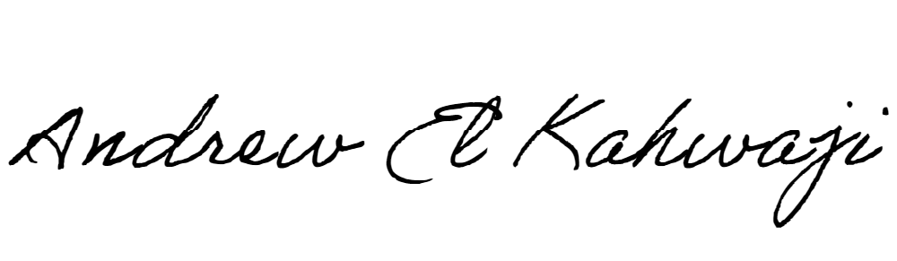

Printed Name _Andrew El Kahwaji_

Date __26/12/2024___

Email __andrew.lifesculptor.coo@gmail.com __

Phone __+961 71 914 378__